**Test Case 1: Storage Integration**

* Creation of storage integration object

Input: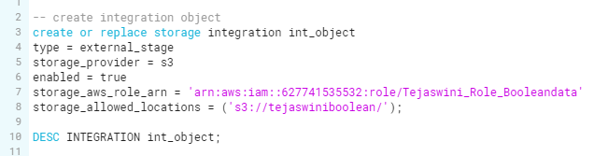Expected output:

* Using storage integration, the expected result to get **External storage id** and **IAM User id** for connect into AWS cloud.

Actual Output:

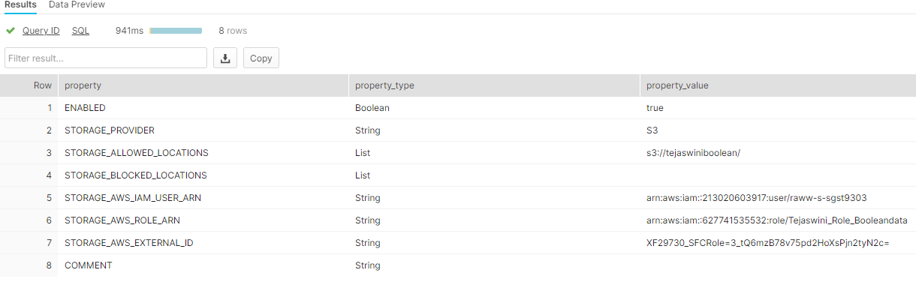

**Test Case 2: Load data from External stage**

Input:

* Using AWS cloud, copy the data into snowflake table

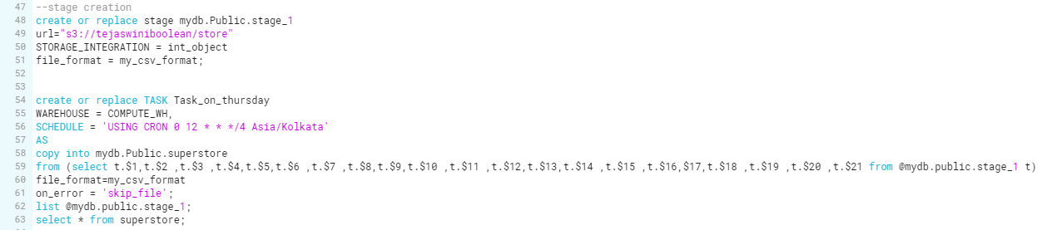Expected output:

* Get all the data from cloud (AWS s3 bucket)

Actual Output:

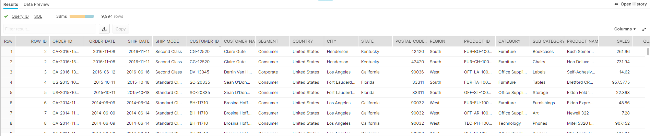

**Test Case 3: Slow dimension changing Type-2**

Input:

* Using SCD2 we are able to get history of data
* Creation of stream on source table and creation of consumer table
* Using merge statement, we can find history of data

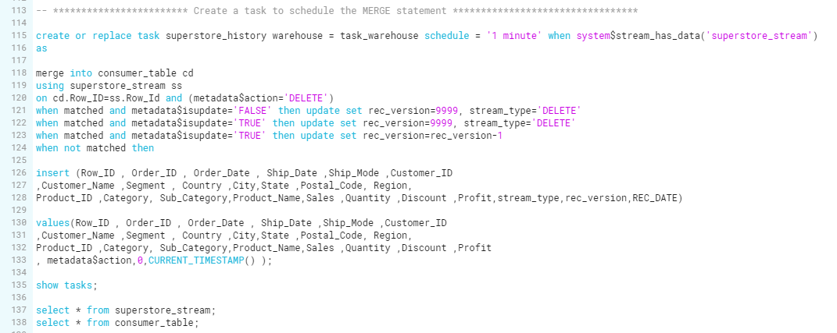Expected Output:

* Expected result is to get history of data after insert or delete from table.

Actual Output:

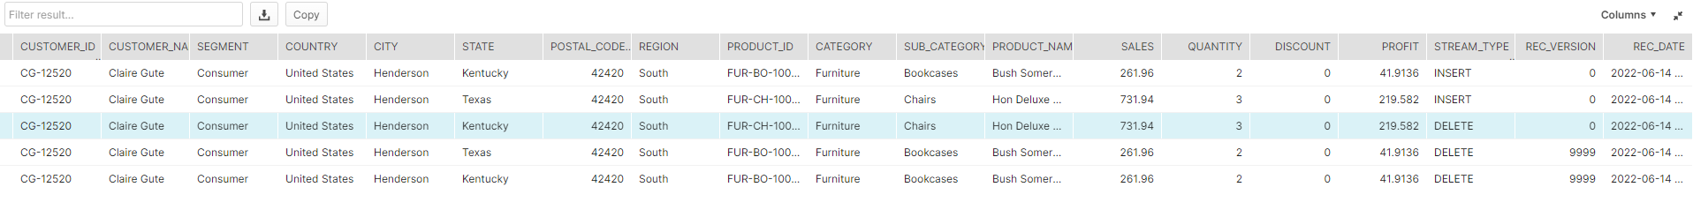

**Test Case 4: Analyze data (Using SQL Query)**

**Case1:**

* Calculating the number of records those with ship mode as Second class

Input:

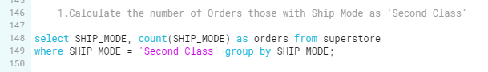

Expected output:

* Expected result is to get total number of records those with ship mode as second class.

Actual output:

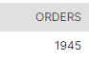

**Case 2:**

* Calculating the valuable customers country wise

Input:

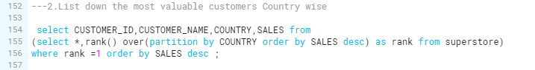

Expected output:

* Expected result is to get most valuable customers country wise.

Actual Output:

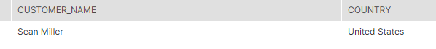

**Case 3:**

* Calculating total sales for category wise.

Input:

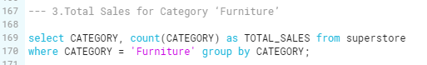Expected output:

* Expected result is to get total sales for category wise

Actual Output:

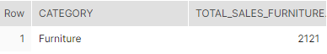

**Case 4:**

Input:

* Calculating maximum profit of products



Expected output:

* Expected result is to get maximum profit of the products.

Actual output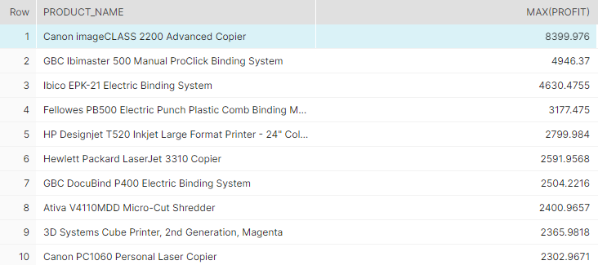

**Case 5:**

* Calculating total profit made by each product, category and country wise

Input: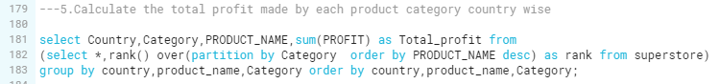**Expected output:**

* Expected result is to get total profit made by each product, category and country wise.

**Actual Output:**

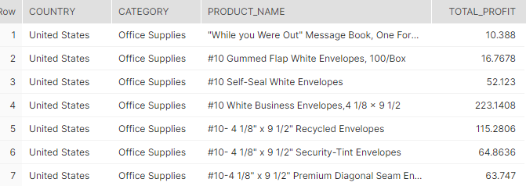

**Case 6:**

* Calculating majority loss with each region country wise.

Input:



Expected output:

* Expected result is to get majority loss with each region country wise.

Actual Output:

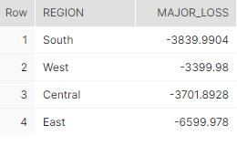

**Test Case 5: Row level Security**

* Creating users and role for accessing the region wise data to specific users
* Creation of secure view
* Grant’s privileges for specific users

Input:

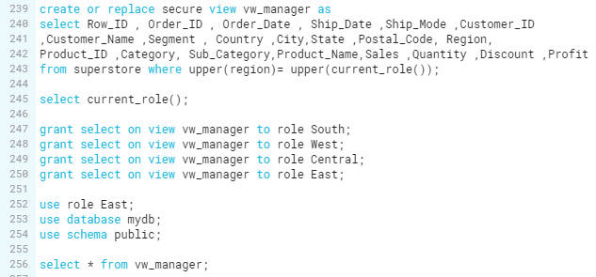Expected Output:

* Expected result is to get specific data for specific user

Actual Output:

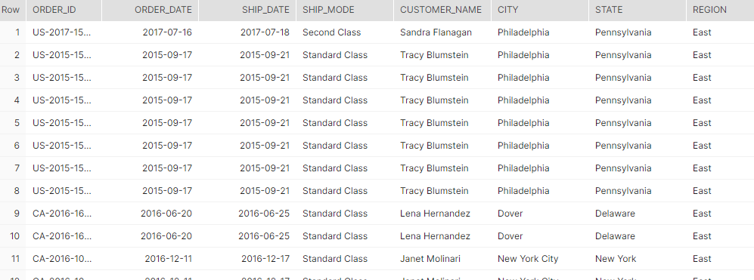

**Test Case 6: CSV File Converted into JSON format using python**

* Converting csv file into JSON format

Input:

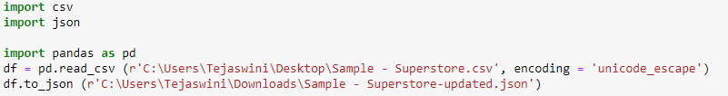

Expected output:

* Expected result is to get data in JSON format

Actual Output:

